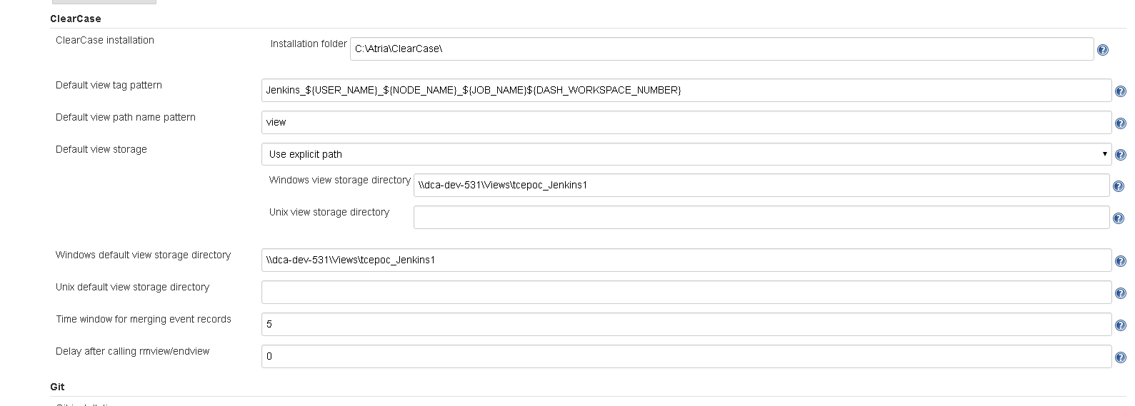

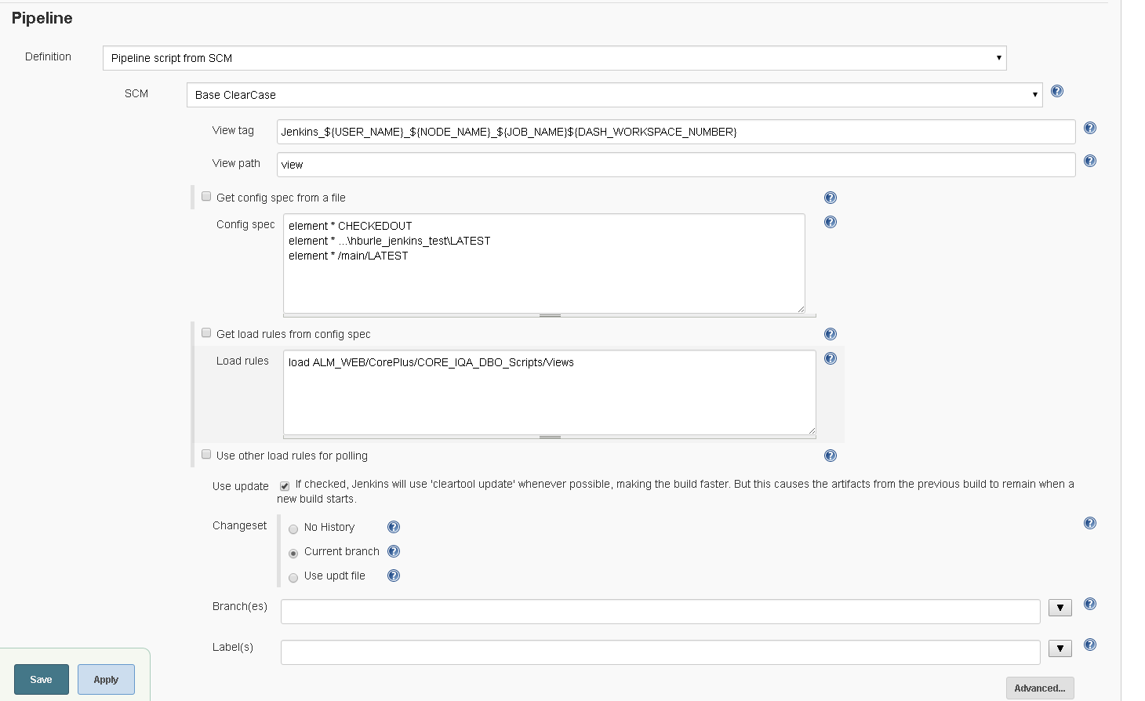
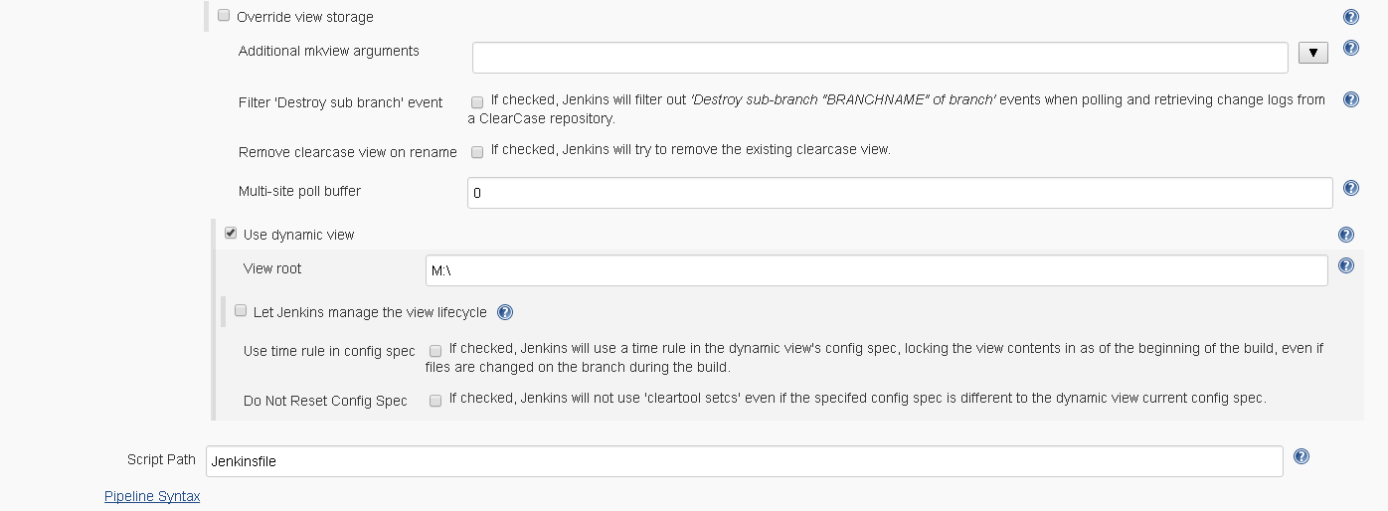

A problem occurred while processing the request. Please check our bug tracker to see if a similar problem has already been reported. If it is already reported, please vote and put a comment on it to let us gauge the impact of the problem. If you think this is a new issue, please file a new issue. When you file an issue, make sure to add the entire stack trace, along with the version of Jenkins and relevant plugins. The users list might be also useful in understanding what has happened.

Stack trace
javax.servlet.ServletException: java.lang.IllegalArgumentException: Failed to instantiate class org.jenkinsci.plugins.workflow.flow.FlowDefinition from {"":"2","scm":{"viewname":"Jenkins_${USER_NAME}_${NODE_NAME}_${JOB_NAME}${DASH_WORKSPACE_NUMBER}","viewpath":"view","configspec":"element * CHECKEDOUT\nelement * ...\\hburle_jenkins_test\\LATEST\nelement * /main/LATEST","extractLoadRules":{"loadrules":"load ALM_WEB/CorePlus/CORE_IQA_DBO_Scripts/Views"},"useupdate":true,"changeset":{"value":"branch"},"branch":"","label":"","excludedRegions":"","mkviewoptionalparam":"","filterOutDestroySubBranchEvent":false,"rmviewonrename":false,"multiSitePollBuffer":"","stapler-class":"hudson.plugins.clearcase.ClearCaseSCM","$class":"hudson.plugins.clearcase.ClearCaseSCM"},"scriptPath":"Jenkinsfile","stapler-class":"org.jenkinsci.plugins.workflow.cps.CpsScmFlowDefinition","$class":"org.jenkinsci.plugins.workflow.cps.CpsScmFlowDefinition"}
at org.kohsuke.stapler.Stapler.tryInvoke(Stapler.java:796)
at org.kohsuke.stapler.Stapler.invoke(Stapler.java:876)
at org.kohsuke.stapler.MetaClass$5.doDispatch(MetaClass.java:233)
at org.kohsuke.stapler.NameBasedDispatcher.dispatch(NameBasedDispatcher.java:58)
at org.kohsuke.stapler.Stapler.tryInvoke(Stapler.java:746)
at org.kohsuke.stapler.Stapler.invoke(Stapler.java:876)
at org.kohsuke.stapler.Stapler.invoke(Stapler.java:649)
at org.kohsuke.stapler.Stapler.service(Stapler.java:238)
at javax.servlet.http.HttpServlet.service(HttpServlet.java:790)
at org.eclipse.jetty.servlet.ServletHolder.handle(ServletHolder.java:812)
at org.eclipse.jetty.servlet.ServletHandler$CachedChain.doFilter(ServletHandler.java:1669)
at hudson.util.PluginServletFilter$1.doFilter(PluginServletFilter.java:135)
at org.jenkinsci.plugins.ssegateway.Endpoint$SSEListenChannelFilter.doFilter(Endpoint.java:206)
at hudson.util.PluginServletFilter$1.doFilter(PluginServletFilter.java:132)
at io.jenkins.blueocean.ResourceCacheControl.doFilter(ResourceCacheControl.java:134)
at hudson.util.PluginServletFilter$1.doFilter(PluginServletFilter.java:132)
at jenkins.metrics.impl.MetricsFilter.doFilter(MetricsFilter.java:125)
at hudson.util.PluginServletFilter$1.doFilter(PluginServletFilter.java:132)
at hudson.util.PluginServletFilter.doFilter(PluginServletFilter.java:126)
at org.eclipse.jetty.servlet.ServletHandler$CachedChain.doFilter(ServletHandler.java:1652)
at hudson.security.csrf.CrumbFilter.doFilter(CrumbFilter.java:80)
at org.eclipse.jetty.servlet.ServletHandler$CachedChain.doFilter(ServletHandler.java:1652)
at hudson.security.ChainedServletFilter$1.doFilter(ChainedServletFilter.java:84)
at hudson.security.UnwrapSecurityExceptionFilter.doFilter(UnwrapSecurityExceptionFilter.java:51)
at hudson.security.ChainedServletFilter$1.doFilter(ChainedServletFilter.java:87)
at jenkins.security.ExceptionTranslationFilter.doFilter(ExceptionTranslationFilter.java:117)
at hudson.security.ChainedServletFilter$1.doFilter(ChainedServletFilter.java:87)
at org.acegisecurity.providers.anonymous.AnonymousProcessingFilter.doFilter(AnonymousProcessingFilter.java:125)
at hudson.security.ChainedServletFilter$1.doFilter(ChainedServletFilter.java:87)
at org.acegisecurity.ui.rememberme.RememberMeProcessingFilter.doFilter(RememberMeProcessingFilter.java:142)
at hudson.security.ChainedServletFilter$1.doFilter(ChainedServletFilter.java:87)
at org.acegisecurity.ui.AbstractProcessingFilter.doFilter(AbstractProcessingFilter.java:271)
at hudson.security.ChainedServletFilter$1.doFilter(ChainedServletFilter.java:87)
at jenkins.security.BasicHeaderProcessor.doFilter(BasicHeaderProcessor.java:93)
at hudson.security.ChainedServletFilter$1.doFilter(ChainedServletFilter.java:87)
at org.acegisecurity.context.HttpSessionContextIntegrationFilter.doFilter(HttpSessionContextIntegrationFilter.java:249)
at hudson.security.HttpSessionContextIntegrationFilter2.doFilter(HttpSessionContextIntegrationFilter2.java:67)
at hudson.security.ChainedServletFilter$1.doFilter(ChainedServletFilter.java:87)
at hudson.security.ChainedServletFilter.doFilter(ChainedServletFilter.java:76)
at hudson.security.HudsonFilter.doFilter(HudsonFilter.java:171)
at org.eclipse.jetty.servlet.ServletHandler$CachedChain.doFilter(ServletHandler.java:1652)
at org.kohsuke.stapler.compression.CompressionFilter.doFilter(CompressionFilter.java:49)
at org.eclipse.jetty.servlet.ServletHandler$CachedChain.doFilter(ServletHandler.java:1652)
at hudson.util.CharacterEncodingFilter.doFilter(CharacterEncodingFilter.java:82)
at org.eclipse.jetty.servlet.ServletHandler$CachedChain.doFilter(ServletHandler.java:1652)
at org.kohsuke.stapler.DiagnosticThreadNameFilter.doFilter(DiagnosticThreadNameFilter.java:30)
at org.eclipse.jetty.servlet.ServletHandler$CachedChain.doFilter(ServletHandler.java:1652)
at org.eclipse.jetty.servlet.ServletHandler.doHandle(ServletHandler.java:585)
at org.eclipse.jetty.server.handler.ScopedHandler.handle(ScopedHandler.java:143)
at org.eclipse.jetty.security.SecurityHandler.handle(SecurityHandler.java:553)
at org.eclipse.jetty.server.session.SessionHandler.doHandle(SessionHandler.java:223)
at org.eclipse.jetty.server.handler.ContextHandler.doHandle(ContextHandler.java:1127)
at org.eclipse.jetty.servlet.ServletHandler.doScope(ServletHandler.java:515)
at org.eclipse.jetty.server.session.SessionHandler.doScope(SessionHandler.java:185)
at org.eclipse.jetty.server.handler.ContextHandler.doScope(ContextHandler.java:1061)
at org.eclipse.jetty.server.handler.ScopedHandler.handle(ScopedHandler.java:141)
at org.eclipse.jetty.server.handler.HandlerWrapper.handle(HandlerWrapper.java:97)
at org.eclipse.jetty.server.Server.handle(Server.java:499)
at org.eclipse.jetty.server.HttpChannel.handle(HttpChannel.java:311)
at org.eclipse.jetty.server.HttpConnection.onFillable(HttpConnection.java:257)
at org.eclipse.jetty.io.AbstractConnection$2.run(AbstractConnection.java:544)
at winstone.BoundedExecutorService$1.run(BoundedExecutorService.java:77)
at java.util.concurrent.ThreadPoolExecutor.runWorker(ThreadPoolExecutor.java:1142)
at java.util.concurrent.ThreadPoolExecutor$Worker.run(ThreadPoolExecutor.java:617)
at java.lang.Thread.run(Thread.java:745)
Caused by: java.lang.IllegalArgumentException: Failed to instantiate class org.jenkinsci.plugins.workflow.flow.FlowDefinition from {"":"2","scm":{"viewname":"Jenkins_${USER_NAME}_${NODE_NAME}_${JOB_NAME}${DASH_WORKSPACE_NUMBER}","viewpath":"view","configspec":"element * CHECKEDOUT\nelement * ...\\hburle_jenkins_test\\LATEST\nelement * /main/LATEST","extractLoadRules":{"loadrules":"load ALM_WEB/CorePlus/CORE_IQA_DBO_Scripts/Views"},"useupdate":true,"changeset":{"value":"branch"},"branch":"","label":"","excludedRegions":"","mkviewoptionalparam":"","filterOutDestroySubBranchEvent":false,"rmviewonrename":false,"multiSitePollBuffer":"","stapler-class":"hudson.plugins.clearcase.ClearCaseSCM","$class":"hudson.plugins.clearcase.ClearCaseSCM"},"scriptPath":"Jenkinsfile","stapler-class":"org.jenkinsci.plugins.workflow.cps.CpsScmFlowDefinition","$class":"org.jenkinsci.plugins.workflow.cps.CpsScmFlowDefinition"}
at org.kohsuke.stapler.RequestImpl$TypePair.convertJSON(RequestImpl.java:676)
at org.kohsuke.stapler.RequestImpl.bindJSON(RequestImpl.java:478)
at org.kohsuke.stapler.RequestImpl.bindJSON(RequestImpl.java:474)
at org.jenkinsci.plugins.workflow.job.WorkflowJob.submit(WorkflowJob.java:190)
at hudson.model.Job.doConfigSubmit(Job.java:1246)
at sun.reflect.GeneratedMethodAccessor1110.invoke(Unknown Source)
at sun.reflect.DelegatingMethodAccessorImpl.invoke(DelegatingMethodAccessorImpl.java:43)
at java.lang.reflect.Method.invoke(Method.java:498)
at org.kohsuke.stapler.Function$InstanceFunction.invoke(Function.java:324)
at org.kohsuke.stapler.interceptor.RequirePOST$Processor.invoke(RequirePOST.java:52)
at org.kohsuke.stapler.PreInvokeInterceptedFunction.invoke(PreInvokeInterceptedFunction.java:26)
at org.kohsuke.stapler.Function.bindAndInvoke(Function.java:167)
at org.kohsuke.stapler.Function.bindAndInvokeAndServeResponse(Function.java:100)
at org.kohsuke.stapler.MetaClass$1.doDispatch(MetaClass.java:124)
at org.kohsuke.stapler.NameBasedDispatcher.dispatch(NameBasedDispatcher.java:58)
at org.kohsuke.stapler.Stapler.tryInvoke(Stapler.java:746)
... 64 more
Caused by: java.lang.IllegalArgumentException: Failed to convert the scm parameter of the constructor public org.jenkinsci.plugins.workflow.cps.CpsScmFlowDefinition(hudson.scm.SCM,java.lang.String)
at org.kohsuke.stapler.RequestImpl.instantiate(RequestImpl.java:773)
at org.kohsuke.stapler.RequestImpl.access$200(RequestImpl.java:83)
at org.kohsuke.stapler.RequestImpl$TypePair.convertJSON(RequestImpl.java:674)
... 79 more
Caused by: java.lang.IllegalArgumentException: Failed to instantiate class hudson.scm.SCM from {"viewname":"Jenkins_${USER_NAME}_${NODE_NAME}_${JOB_NAME}${DASH_WORKSPACE_NUMBER}","viewpath":"view","configspec":"element * CHECKEDOUT\nelement * ...\\hburle_jenkins_test\\LATEST\nelement * /main/LATEST","extractLoadRules":{"loadrules":"load ALM_WEB/CorePlus/CORE_IQA_DBO_Scripts/Views"},"useupdate":true,"changeset":{"value":"branch"},"branch":"","label":"","excludedRegions":"","mkviewoptionalparam":"","filterOutDestroySubBranchEvent":false,"rmviewonrename":false,"multiSitePollBuffer":"","stapler-class":"hudson.plugins.clearcase.ClearCaseSCM","$class":"hudson.plugins.clearcase.ClearCaseSCM"}
at org.kohsuke.stapler.RequestImpl$TypePair.convertJSON(RequestImpl.java:676)
at org.kohsuke.stapler.RequestImpl.bindJSON(RequestImpl.java:478)
at org.kohsuke.stapler.RequestImpl.instantiate(RequestImpl.java:771)
... 81 more
Caused by: java.lang.IllegalArgumentException: Failed to convert the extractLoadRules parameter of the constructor public hudson.plugins.clearcase.ClearCaseSCM(java.lang.String,java.lang.String,boolean,java.lang.String,boolean,java.lang.String,java.lang.String,java.lang.String,boolean,boolean,java.lang.String,boolean,java.lang.String,boolean,java.lang.String,java.lang.String,boolean,boolean,boolean,java.lang.String,java.lang.String,boolean,boolean,java.lang.String,hudson.plugins.clearcase.AbstractClearCaseScm$ChangeSetLevel,hudson.plugins.clearcase.viewstorage.ViewStorage)
at org.kohsuke.stapler.RequestImpl.instantiate(RequestImpl.java:773)
at org.kohsuke.stapler.RequestImpl.access$200(RequestImpl.java:83)
at org.kohsuke.stapler.RequestImpl$TypePair.convertJSON(RequestImpl.java:674)
... 83 more
Caused by: java.lang.IllegalArgumentException: Failed to instantiate boolean from {"loadrules":"load ALM_WEB/CorePlus/CORE_IQA_DBO_Scripts/Views"}
at org.kohsuke.stapler.RequestImpl$TypePair.convertJSON(RequestImpl.java:676)
at org.kohsuke.stapler.RequestImpl.bindJSON(RequestImpl.java:478)
at org.kohsuke.stapler.RequestImpl.instantiate(RequestImpl.java:771)
... 85 more
Caused by: org.kohsuke.stapler.NoStaplerConstructorException: There's no @DataBoundConstructor on any constructor of boolean
at org.kohsuke.stapler.ClassDescriptor.loadConstructorParamNames(ClassDescriptor.java:247)
at org.kohsuke.stapler.RequestImpl.instantiate(RequestImpl.java:758)
at org.kohsuke.stapler.RequestImpl.access$200(RequestImpl.java:83)
at org.kohsuke.stapler.RequestImpl$TypePair.convertJSON(RequestImpl.java:674)
... 87 more

